Introduction to Computational and Biological Vision final project

Golden face grade

By Adi Sherf

ads@post.bgu.ac.il

And Yael Gabay

gabayy@post.bgu.ac.il

1. Introduction

1.1 What is the golden ratio?
The golden ratio is based on Fibonacci Numbers, where every number in the sequence (after the second) is the sum of the previous 2 numbers:
1, 1, 2, 3, 5, 8, 13, 21, ...
Let's look at the ratio of each number in the Fibonacci sequence to the one before it, from a certain point we produce an interesting number which mathematicians call "phi": $Φ = 1.618 033 988 7... =\frac{1+\sqrt{5}}{2}$
This is the golden ratio.
Why is the golden proportion so special? is there any difference between the golden proportion and another pleasing proportion?
Let's look at lines division:
Lines divided in any proportion | Divided in golden proportion
$$\frac{AB}{BC}=\frac{2}{5}=0.4$$ | $$\frac{AB}{BC}=\frac{0.618}{1}=0.618$$
$$\frac{BC}{AC}=\frac{5}{7}=0.71$$ | $$\frac{BC}{AC}=\frac{1}{1.618}=0.618$$
The two equations give different answers. | The two equations give identical answers.

The proportion of the smaller to the greater is the same as the proportion of the greater to the whole. The only time that these two proportions are the same is when they are "Golden".
This point of division is a mathematical confirmation of how the eye senses the balance of this magical proportion that appears so frequently in nature and art.
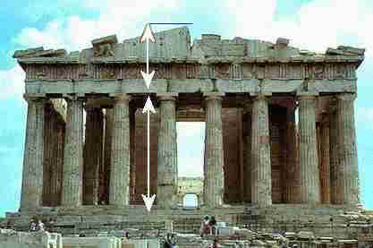
This ratio was used by architects and artists throughout history to produce objects of great beauty (like Michelangelo's "David" and the Greek temples).

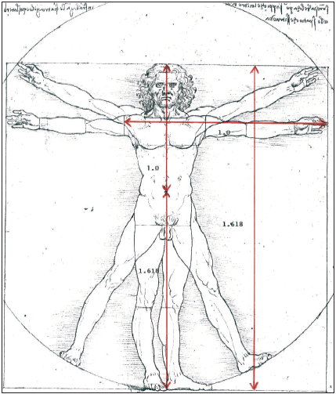
Da Vinci himself used it when he drew the perfect human male body in his famous work the Virtruvian Man.

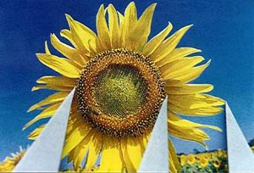
The Golden Ratio also occurs in nature, in the patterns we see in sunflowers, pine cones and so on.

1.2 Why golden ratio pleases the eye?

The pioneering experiments in this field were conducted by the German physicist and psychologist Gustav Theodor Fechner in the 1860s. Fechner's experiment was simple: ten rectangles varying in their length-to-width ratios were placed in front of a subject, who was asked to select the most pleasing one. The results showed that 76% of all choices centered on the three rectangles having ratios of 1.75, 1.62, and 1.50, with a peak at the "Golden Rectangle" (with ratio 1.62). Fechner went further and measured the dimensions of thousands of rectangular-shaped objects (windows, picture frames in the museums, books in the library), and claimed (in his book Vorschule der Aesthetik) to have found the average ratio to be close to the golden ratio.

According to Adrian Bejan[1], the human eye is capable of interpreting an image featuring the golden ratio faster than any other.
Bejan says that whether intentional or not, the ratio represents the best proportions to transfer to the brain.
"Shapes with length/height ratios (L/H) close to 3/2 are everywhere and give the impression that they are being ‘designed’ to match the golden ratio (φ = 1.618). …The time required by the eyes to scan a rectangular area L x H is minimal when the shape is L/H = VL/VH, where VL and VH are the horizontal and vertical scanning speeds. … I also show that VL/VH is approximately 3/2 and that consequently L/H ~ 3/2. … Vision, cognition and locomotion are features of a single design for movement of animal mass with easier and easier access in time, all over the globe".
"We really want to get on, we don't want to get headaches while we are scanning and recording and understanding things," he said. "Animals are wired to feel better and better when they are helped and so they feel pleasure when they find food or shelter or a mate. When we see the proportions in the golden ratio, we are helped. We feel pleasure and we call it beauty."

1.3 "What is this "Phi Mask"?

Dr Stephen Marquartdt [3] developed a facial mask as a measurement of classic beauty to help plastic surgeons align facial features for more symmetrical accuracy based on a series of rectangles, triangles and decagons.

The more attractive or beautiful a face is the more closely it will match the mask:
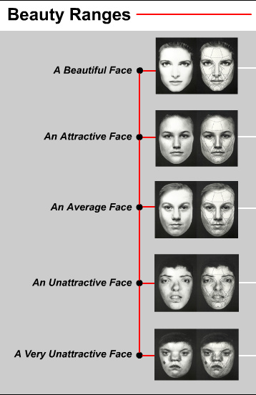

"We believe that it is not strictly an image of "beauty" - but actually an image of "HUMANNESS". That is, it is the way we identify our own species, and individuals within our species. … Other animals recognize their own species through one or a combination of their senses. … Humans are animals, but more specifically we are a visual animal. We essentially recognize each other by sight. … The primary image of "humanness" is the genetically coded visual image of an "ideal" human face. The more a face resembles this "Ideal Human Face Image" - the more we perceive it to be human. …If this subconscious visual perception of "humanness" is strong enough, then the conscious response will be elevated to a combination of a sense of "strong attraction" and a sense of "strong positive emotion". … Thus we can postulate that the perception or "recognition" of beauty is actually nothing more than a strong correlation of what we subconsciously expect "humanness" to appear to be."

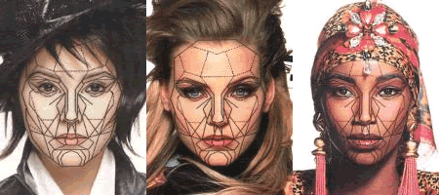

1.4 The new "golden" ratio:

According to Pamela Pallett, Stephen Link, and Kang Lee [4], the ration we consider beautiful are different. In four separate experiments, the researchers asked university students to make paired comparisons of attractiveness between female faces with identical facial features but different eye-mouth distances and different distances between the eyes.
They discovered two "golden ratios," one for length and one for width. Female faces were judged more attractive when the vertical distance between their eyes and the mouth was approximately 36 percent of the face's length, and the horizontal distance between their eyes was approximately 46 percent of the face's width.
Interestingly, these proportions correspond with those of an average face.
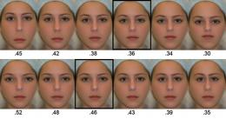
"The ancient Greeks found what they believed was a 'golden ratio' - also known as 'phi', But there was never any proof that the golden ratio was special. As it turns out, it isn't. Instead of phi, we showed that average distances between the eyes, mouth and face contour form the true golden ratios."

1.5 Our goal

We wanted to calculate a grade of a facial image according to the ratios described above, and see if there really is a connection between these measurements and perceived beauty.

2. Approach and Method

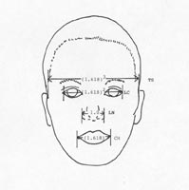
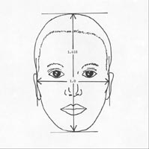
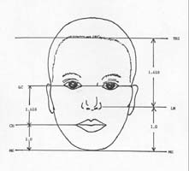
Our goal was obtained by detecting a series of special features points in the facial image and calculating various ratios according to certain distances between them.
For example:

2.1 Facial features extraction - Automatic detection of points

We automatically detected 10 points in the face: pupils and outer eye points, the mouth and its 2 end points, both vertical end points of the face and the horizontal center of the face between both eyes.

We first find the symmetry line of the face using a binary matrix that represents the darker section of the face.

We then estimate the size of the eyes area from the size of the face. We look for an area with the best correlation of edges compared to the average eyes photo (computed from 13 different faces).

Now using the Daugman algorithm [5] (on which we will elaborate later) we look for the pupils in the eyes area, each pupil on another side of the symmetry line.

The rest of the points are detected relative to the pupils according to approximated displacement and expected gradient changes.

2.2 Find pupils with Daugman’s Integro-differential algorithm:

$\max_{r,x_{0},y_{0}}\left|G_{σ}\left(r\right)*\frac{∂}{∂r}\oint_{r,x_{0},y_{0}}{\frac{I\left(x,y\right)}{2πr}ds}\right|$
In order to find the pupil (the center of the Iris) we look for (r, x₀, y₀) that maximizes (1), where (x₀, y₀) is the center of the iris (and the pupil) and r is its radius.
The integral sums the average intensity of a circle with radius r. therefore if the circle has uniform intensity its contribution will be the same, therefor the maximum value will be at the perimeter of the iris – where the intensity changes dramatically.

One problem is that the illumination inside the pupil is a perfect circle with very high intensity level (nearly pure white). So a minimum pupil radius should be set.

This algorithm resembles the Hough Transform algorithm a little, but is less sensitive to errors. Daugman's algorithm showed better results on most pictures and yet erred in some.

2.3 Other useful methods:

The most common method for extracting facial features and face recognition is based on the Viola-Jones algorithm, which is machine learning. We chose not to use it since we wanted to experiment finding the features ourselves.

2.4 Survey

We asked 28 participants to order a set of 20 facial images according to their beauty and compared the results to the ordering according to the 2 different beauty ratios suggested.

3. Results

Survey results compared with ranks according to ratios

The results of the set of pictures as a whole show no obvious connection to the measurements according to both ratios, suggesting we "see" more than just ratios as beauty. We may be influenced also by color, expression, age and gender.

It seems that the new "golden" grade has better correlation with the survey results, although ambiguously.

However, a few interesting points arise:

Most pictures received similar (relatively high) grade, indicating that the average face's ratios are close to the golden ratio.

Almost all faces received a high grade according to the new ratios, consistent with the findings of Pallett, Link & Lee.

Among the 20 pictures were a picture of a women and a picture altered from the first picture creating better proportions:

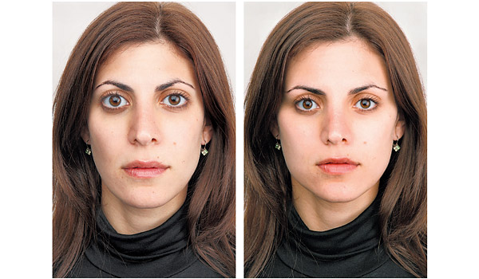

In this case all results consistently and unambiguously showed a preference to the right picture (the one after alteration).

Feature detecting results

Under some assumptions (the angle of the face, little shading, uniform background, image quality, etc.) most pictures yielded good results.

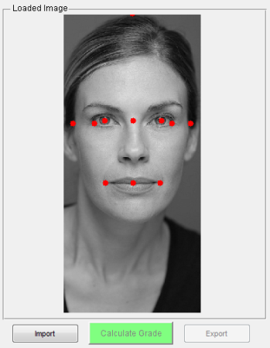
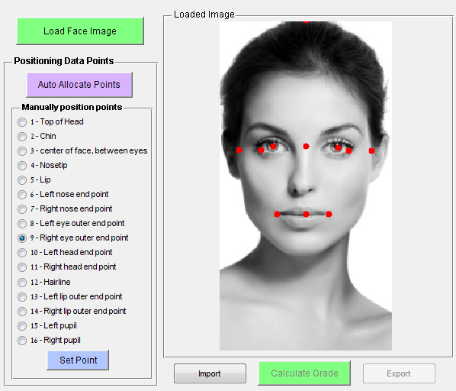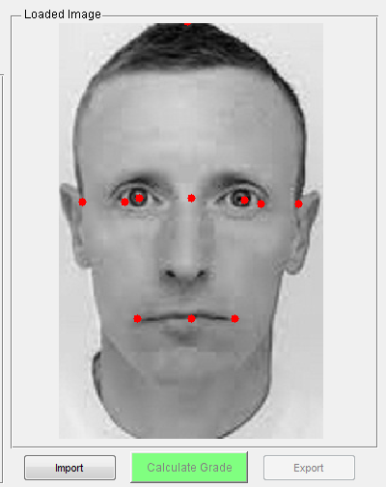

In some pictures we failed to recognize the points correctly, mostly due to loose hair, a smile, shading, facial hair or wrinkles.

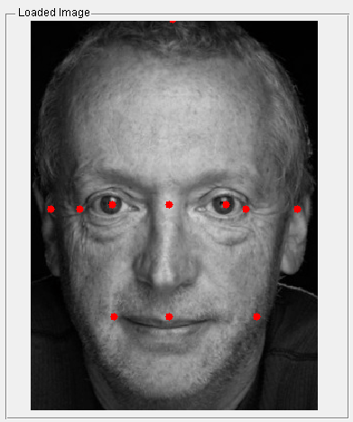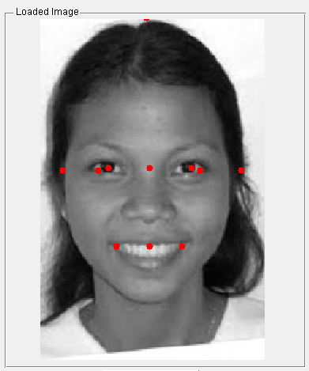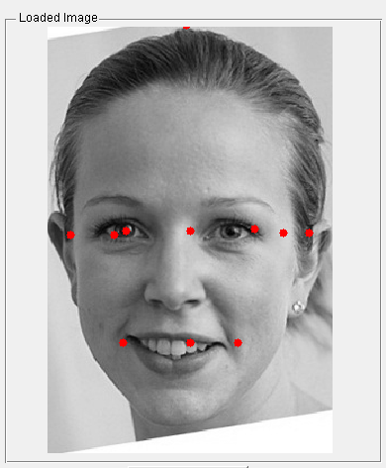

4. Conclusions

We expected to find better correlation between perceiving beauty and the existence of certain ratios in the image we see.

What we found was that the golden ratio is only a part of the characteristics that form our concept of beauty.

It is clear, though, that this golden ratio surrounds us, and we do seem to prefer it.

4.1 An ethical dilemma

A question arose whether such a computer program, receiving a photo and calculating its grade is ethic. After all, this kind of program that reduces a person to a single grade, based on geometry alone, ignores a lot of other features that make us human. Surely there is more to beauty than just geometrical ratios.

How would this sort of software be used?
Is the science behind it really correct? Who are we to determine what is beautiful?

We think that there's a reason for saying: "The beauty is in the eyes of the beholder".

5. Improvements

Better results in detecting features can be obtained using the more complex Viola-Jones algorithm.

Also, the next step would be to locate all 16 points automatically (we manually set 6 of them).

In order to improve the meaning of the survey results, we think a more suitable experiment would be to conduct a series of test sets, each one consisting of faces with similar features, differentiating mostly by proportions, and of same gender (similar to the example presented in 3.1.d).

6. References

[1] Bejan, A., The golden ratio predicted: vision, cognition and locomotion as a single design in nature, 2009.

[2] Livio, M., The golden section, 2002.

[3] Dr Stephen Marquardt's website: http://www.beautyanalysis.com

[4] Pallett, M., Link, S. & Lee, K., New golden ratios for facial beauty, 2009.

[5] John G. Daugman. J., High confidence visual recognition of persons for a test of statistical independence.

